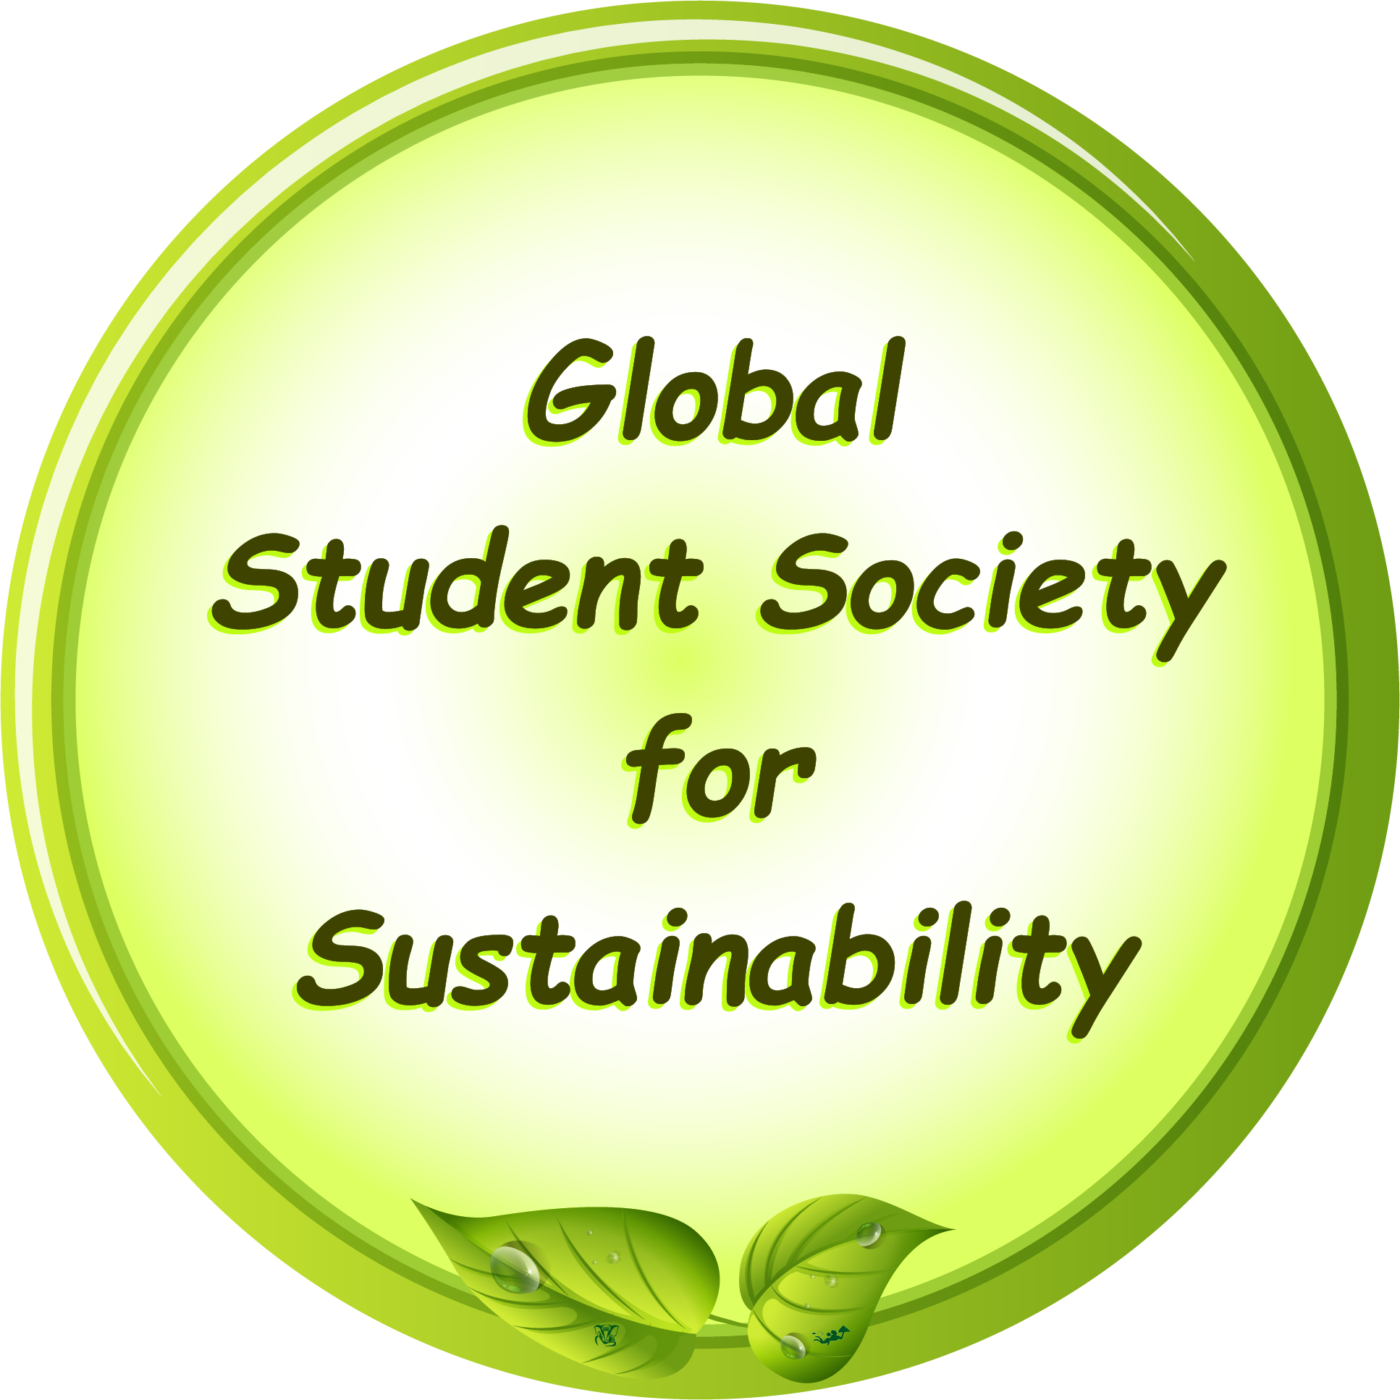 | Memorandum of Understanding (MoU)  Between  Global Student Society for Sustainability (GSSS) | Logo of Partner
And
[Partner Institution’s Name]
- Purpose of the MoU
The purpose of this Memorandum of Understanding (MoU) is to establish a collaborative partnership between the Global Student Society for Sustainability (GSSS) and [Partner Institution’s Name] to promote sustainable development practices, environmental education, and impactful community engagement through the formation of a GSSS Student Chapter at the Partner Institution. This MoU outlines mutual responsibilities, benefits, and expectations for the successful operation of the student chapter.
- Benefits to the Partner Institution
By partnering with GSSS to establish a Student Chapter, [Partner Institution’s Name] will gain the following benefits:
- Enhancement for Accreditation: Establishing the GSSS Student Chapter will contribute positively to accreditation standards, including NAAC, NBA, and others, as it demonstrates the institution’s commitment to sustainability and community engagement, showcasing the institute’s dedication to student development and environmental initiatives.
- Logo of GSSS: [Partner Institution’s Name] can use GSSS logo on website as well as marketing material after completion of signing formalities of this MOU by both parties.
- Badge of Student Chapter: [Partner Institution’s Name] will receive an official badge from GSSS, recognizing the establishment of the Student Chapter.
- Certificate of Student Chapter: [Partner Institution’s Name] will receive an official certificate from GSSS, recognizing the operation of the Student Chapter.
- Recognition for Sustainability Initiatives: The institution’s commitment to sustainability will be highlighted, offering valuable recognition at a national and international level through GSSS channels.
- Minimum Student Strength Requirement
To establish and operate the GSSS Student Chapter, a minimum of 20 students is required. This minimum ensures an active and engaged membership base, fostering successful chapter activities and participation.
- Registration Charges and Financial Guidelines

Each student member is required to pay a registration fee of Rs. 100 upon joining the chapter. Financial usage and management for the funds collected are outlined as follows:
- Year 1 Usage: In the first year, 100% of the registration fees collected may be used by the institution for organizing and conducting GSSS chapter activities. The institution must maintain a balance sheet of expenditures for transparency and reporting purposes.
- Year 2 and Beyond: For subsequent years, 50% of the registration fees collected may be used by the institution for organizing. Balance 50% should be donated to GSSS to maintain & promote this not-for-profit initiative.

5. Activity Requirements
- The institution must conduct a minimum of two activities per academic year under the GSSS Student Chapter. These activities should align with GSSS's mission and values, promoting sustainability, environmental awareness, or community engagement.
- Activity Reporting: For each activity, the institution is required to upload an activity report to the GSSS portal, including Geo-tagged photos and details of the event. This ensures proper documentation and visibility of chapter activities.

6. Responsibilities of the Parties

Responsibilities of GSSS
- Provide guidance, resources, and support for organizing chapter activities.
- Issue an official badge & certificate recognizing the establishment & operation of the student chapter.
- Facilitate access to international networks, workshops, and events aligned with sustainability.
- Ensure chapter visibility and recognition on GSSS’s official website and communication channels.

Responsibilities of the Partner Institution
- Ensure a minimum membership of 20 students for the establishment and continuation of the chapter.
- Collect registration fees and manage the allocated budget as per the terms outlined above.
- Conduct a minimum of Two Activities each year, in line with GSSS’s mission and sustainability goals.
- Maintain transparent financial records of collected funds and report as required by GSSS.
- Submit an activity report, including geo-tagged photos, to the GSSS portal for each chapter event.
- Ensure chapter visibility and recognition on [Partner Institution’s Name] a dedicated official website page and/or a dedicated LinkedIn page and/or a dedicated Facebook page.

7. Duration and Renewal
This MoU will remain effective for a period of two years from the date of signing and may be renewed upon mutual consent of both parties.

8. Amendments
Any amendments to this MoU will require the written approval of both parties and must be signed by the authorized representatives.

9. Termination
Either party may terminate this MoU with a 60-day written notice to the other party.

Signatures

Global Student Society for Sustainability (GSSS)  [Dr Anil Dube]  [Director – GSSS – Global Operation]  [Date] | [Partner Institution’s Name]  [Name of the Authorized Signatory]  [Designation]  [Date]

